development language：JavaScript、VB、C#
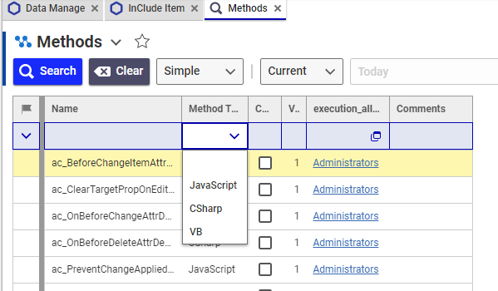
development tool：
- Aras Innovator CodeEditor
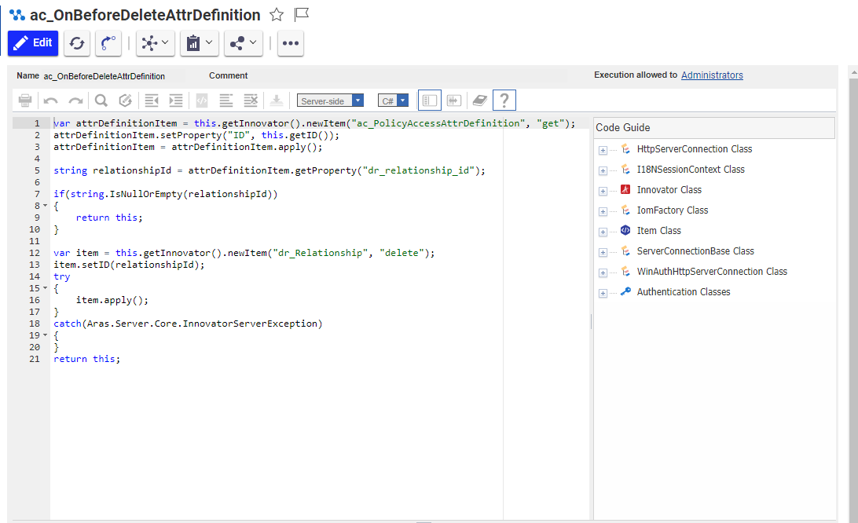
- Visual Studio Code
